Q1.

package q1;  
  
import java.util.Scanner;  
  
public class LessThan {  
 public static void main(String[] args) {  
 Scanner sc = new Scanner(System.*in*);  
  
 //input the inputs  
 System.*out*.println("Enter 1st number: ");  
 int a = sc.nextInt();  
 System.*out*.println("Enter 2nd number: ");  
 int b = sc.nextInt();  
 System.*out*.println("Enter 3rd number: ");  
 int c = sc.nextInt();  
  
 //find the smallest number  
 if (a <b && a <c){  
 System.*out*.println("Smaller number is: " + a);  
 }  
 else if (b <a && b <c){  
 System.*out*.println("Smaller number is: " + b);  
 }  
 else{  
 System.*out*.println("Smaller number is: " + c);  
 }  
 }  
  
}

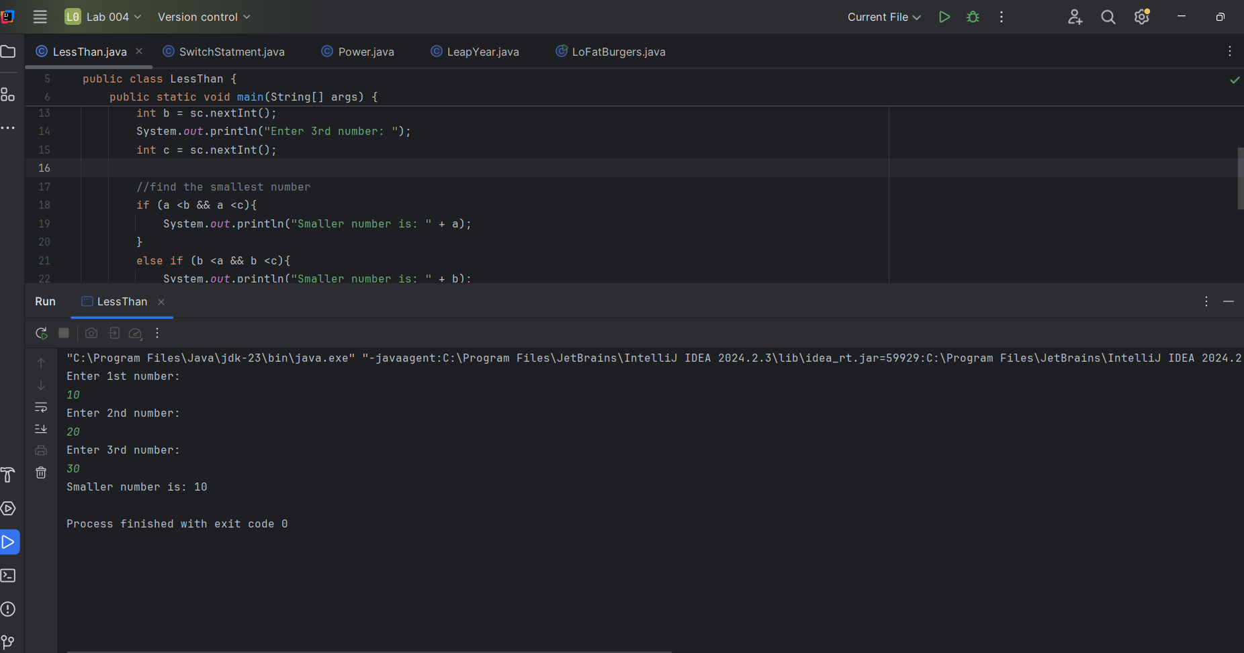

Q2.

package q2;  
  
import java.util.Scanner;  
  
public class SwitchStatment {  
 public static void main(String[] args) {  
 Scanner scanner = new Scanner(System.*in*);  
 System.*out*.println("0.Magenta");  
 System.*out*.println("1.Cyan");  
 System.*out*.println("2.Red");  
 System.*out*.println("3.Blue");  
 System.*out*.println("4.Green");  
 System.*out*.println("Select one color from the above list:");  
  
 int selection = scanner.nextInt();  
  
 switch (selection) {  
 case 0:  
 System.*out*.println("You selected Magenta");  
 break;  
 case 1:  
 System.*out*.println("You selected Cyan");  
 break;  
 case 2:  
 System.*out*.println("You selected Red");  
 break;  
 case 3:  
 System.*out*.println("You selected Blue");  
 break;  
 case 4:  
 System.*out*.println("You selected Green");  
 break;  
 default:  
 System.*out*.println("Invalid selection");  
 break;  
 }  
  
 }  
}

Q3.

package q3;  
  
import java.util.Scanner;  
  
public class Power {  
 public static void main(String[] args) {  
 Scanner sc = new Scanner(System.*in*);  
 System.*out*.println("Enter Power of 10 : /n From (6,9,12,15,18,21,30,100");  
 int power = sc.nextInt();  
  
 String name = "";  
  
  
 switch (power) {  
 case 6:  
 name="MILLION";  
 break;  
 case 9:  
 name="BILLION";  
 break;  
 case 12:  
 name="TRILLION";  
 break;  
 case 15:  
 name="QUADLION";  
 break;  
 case 18:  
 name="Quintillion";  
 break;  
 case 21:  
 name="Sextillion";  
 break;  
 case 30:  
 name="Nonillion";  
 break;  
 case 100:  
 name="Googol";  
 break;  
 default:  
 System.*out*.println("Invalid Power Number");   
 break;  
 }  
  
 System.*out*.println("The Power of 10 of give you equal to = "+ name);  
  
 }  
}

Q4.

package q4;  
  
import java.util.Scanner;  
  
public class LeapYear {  
 public static void main(String[] args) {  
 Scanner scanner = new Scanner(System.*in*);  
  
 //input the year  
 System.*out*.print("Enter a year: ");  
 int year = scanner.nextInt();  
  
 //checking the year  
 if ((year % 4 == 0 && year % 100 != 0) || (year % 400 == 0)) {  
 System.*out*.println(year + " is a Leap Year.");  
 } else {  
 System.*out*.println(year + " is Not a Leap Year.");  
 }  
  
 scanner.close();  
 }  
}

Q5.

package q5;  
  
import java.util.Scanner;  
  
public class LoFatBurgers {  
 public static void main(String[] args) {  
 Scanner input = new Scanner(System.*in*);  
  
 System.*out*.println("Welcome to MyJava Lo-Fat Burgers\n");  
 System.*out*.println("Please choose one item from each category:\n");  
  
 // Entree  
 System.*out*.println("Entree:");  
 System.*out*.println("1. Tofu Burger - $3.49");  
 System.*out*.println("2. Cajun Chicken - $4.59");  
 System.*out*.println("3. Buffalo Wings - $3.99");  
 System.*out*.println("4. Rainbow Fillet - $2.99");  
 System.*out*.print("Enter your choice (1-4): ");  
 int entreeChoice = input.nextInt();  
  
 // Side Dish  
 System.*out*.println("\nSide Dish:");  
 System.*out*.println("1. Rice Cracker - $0.79");  
 System.*out*.println("2. No-Salt Fries - $0.69");  
 System.*out*.println("3. Zucchini - $1.09");  
 System.*out*.println("4. Brown Rice - $0.59");  
 System.*out*.print("Enter your choice (1-4): ");  
 int sideChoice = input.nextInt();  
  
 // Drink  
 System.*out*.println("\nDrink:");  
 System.*out*.println("1. Cafe Mocha - $1.99");  
 System.*out*.println("2. Cafe Latte - $1.90");  
 System.*out*.println("3. Espresso - $2.49");  
 System.*out*.println("4. Oolong Tea - $0.99");  
 System.*out*.print("Enter your choice (1-4): ");  
 int drinkChoice = input.nextInt();  
  
 double entreePrice = 0, sidePrice = 0, drinkPrice = 0;  
  
 switch (entreeChoice) {  
 case 1: entreePrice = 3.49; break;  
 case 2: entreePrice = 4.59; break;  
 case 3: entreePrice = 3.99; break;  
 case 4: entreePrice = 2.99; break;  
 default: System.*out*.println("Invalid entree choice.");  
 }  
  
 switch (sideChoice) {  
 case 1: sidePrice = 0.79; break;  
 case 2: sidePrice = 0.69; break;  
 case 3: sidePrice = 1.09; break;  
 case 4: sidePrice = 0.59; break;  
 default: System.*out*.println("Invalid side choice.");  
 }  
  
 switch (drinkChoice) {  
 case 1: drinkPrice = 1.99; break;  
 case 2: drinkPrice = 1.90; break;  
 case 3: drinkPrice = 2.49; break;  
 case 4: drinkPrice = 0.99; break;  
 default: System.*out*.println("Invalid drink choice.");  
 }  
  
 double total = entreePrice + sidePrice + drinkPrice;  
  
 System.*out*.println("\nYour total is: $" + String.*format*("%.2f", total));  
  
 input.close();  
 }  
}

